|  |  |
| --- | --- |
| **Project Case** |  |
| COMP6232001 | COMP6800 | COMP6800001  Human and Computer Interaction |
| **Computer Science** | **E232-COMP6800-JT04-00** |
| ***Valid on*** *Even Semester Year 2022/2023* | **Revision 00** |

1. Kelompok tidak diperkenankan untuk:

*Members of the group are prohibited from:*

* + - Melihat sebagian atau seluruh jawaban kelompok lain,

*Seeing a part or the whole answer from other groups,*

* + - Menyadur sebagian atau seluruh jawaban dari buku, catatan, video, dan jenis referensi lainnya,

*Retell a part or the whole answer from books, notes, videos, and other references,*

* + - Menyadur sebagian atau seluruh jawaban dari internet,

*Retell a part or the whole answer from the internet,*

* + - Mengumpulkan jawaban yang tidak sesuai dengan tema soal,

*Submitting an answer with a different theme from the given case,*

* + - Melakukan tindakan yang menyebabkan jawaban dicontek oleh orang lain atau kelompok lain, baik disengaja maupun tidak disengaja,

*Doing action that could result the answer being copied by someone or other groups, intentionally or unintentionally,*

* + - Melakukan tindakan kecurangan lainnya.

*Committing other dishonest actions.*

1. Jika kelompok terbukti melakukan tindakan seperti yang dicantumkan pada butir ke-1, maka nilai mahasiswa dan/atau kelompok yang melakukan kecurangan, baik menyontek atau dicontek, akan dinolkan sesuai dengan peraturan yang berlaku.

*If it has been proven that a group has committed dishonest actions outlined in point 1 above, the whole groups related to the incident, regardless of which one copies or has their answer copied, will be issued a score of zero according to the regulation.*

1. Jawaban yang dapat diterima dan dinilai adalah jawaban yang dikumpulkan sebelum batas waktu yang telah ditentukan.

*The answer must be submitted before the designated deadline to be accepted and graded,*

1. Jawaban akan dinilai berdasarkan teknik atau metode yang diajarkan pada kelas praktikum dengan menggunakan software yang sudah ditentukan.

*The scoring will be based on the materials taught during the practicum classes using the designated software. Using different software than requested may result in your answer not being graded.*

1. Jika Anda tidak membaca peraturan ini, maka Anda dianggap sudah membaca dan menyetujuinya.

*By taking this exam, you agree to these regulations, regardless of whether you have read it or not.*

1. Persentase penilaian untuk matakuliah ini adalah sebagai berikut:

*The score will be distributed as follows:*

|  |  |  |
| --- | --- | --- |
| **Tugas Mandiri**  *Assignment* | **Proyek**  *Project* | **UAP**  *Final Exam* |
| - | 100% | - |

1. Perangkat lunak yang digunakan pada matakuliah ini adalah sebagai berikut:

*This course uses the following software:*

|  |
| --- |
| **Software**  *Software* |
| Chrome / Firefox / Microsoft Edge  Figma  Visual Studio Code |

1. Ekstensi file yang harus dikumpulkan untuk matakuliah ini adalah sebagai berikut:

*Your answers must be in the following file extensions:*

|  |  |  |
| --- | --- | --- |
| **Tugas Mandiri**  *Assignment* | **Proyek**  *Project* | **UAP**  *Final Exam* |
| - | FIG, HTML, CSS, JS, Image Files (JPG / PNG) | - |

1. File yang harus dikumpulkan adalah keseluruhan jawaban beserta dengan aset yang digunakan (gambar, audio, video, dll) dan dokumentasi proyek yang berisikan link referensi aset dan penjelasan mengenai aplikasi yang dibuat (terlampir bersama dengan soal).

*Include other files that can support your project, such as: all files in your project, other files (image, audio, video, etc.) used in your project, *.doc file (documentation of your project) that contains all pages in your project, reference links of additional files (image, audio, video, etc.) used in your project, the description about how to use your application, etc.*

## Soal

*Case*

**JeTFlix**

**JeTFlix** is a streaming company that has been developed and explored with all new movies. Its branches are spread all over the world. JeTFlix provides all movies in a practical way and can be opened wherever the customer wants. Because the business has grown so fast. TinTin, manager of JeTFlix wants you to **create a new website** including **the website prototype**. With this new website, hopes JeTFlix can improve customer needs and customer convenience by any rates. -

The **requirements** from JetFlix are described below:

* + - 1. JetFlix wants you to design the **website prototype** of all **five pages** before making the HTML files. The website prototype will be created using **Figma**. Ensure the website prototype that you created is the **exact same** as the website that you will make later. Each pagewill contain **header**, **navigation**, **content,** and **footer** as its structure. Consider the **color**, **layout**, and **consistency** when designing the prototype.
      2. JetFlix wants you to make the **website attractive**, **appealing**, **fully functional**, and make sure the website is **responsive**. The website should be accessible using a mobile phone in a perfect way. To achieve that, use **5 kinds of CSS property** and **JavaScript**. Use **meta** **viewport** **tag** and **media** **screen** **rule** that will be applied if the screen is **below** **768px** screen width.
      3. The website consists of **five main pages**. They are **Home Page**, **News & Popular Page**, **Movies Page**, **Detail Page**, and **Sign-Up Page**. Below are the **requirements** for each page:
  1. **Home Page**

This page shows a **top** **movie** as a background and **form** to redirect to sign up page. This page also contains **information** about **kid’s movie / profile**.

* 1. **News & Popular**

This page provides **information** about the **top 5 movies** on JeTFlix. Don’t forget to show **movie information such as title, cast, genre**. You need to add a **play** button and **download** button for each movie.

* 1. **Movies Page**

This page shows a list of **movies category** and **the movies**. There are 4 categories, and each category has at least **5 movies**. Don’t forget to show the **movie’s image** when the customer sees all the movies. This page has a **jumbotron** which’s show **the best movie in JeTFlix**. The jumbotron has a **detail** such **movie name**, **synopsis**, and **button to** **Detail Page**.

* 1. **Detail Page**

This page shows **the** **best movie in JeTFlix description** such **as cast**, **genre**, **synopsis**, **creator**, **and all the episodes**. The episodes need to show the description such as **image** (**random clip from the episode**), **title**, **description**, **and duration**.

* 1. **Sign Up**

This page provides a **register** **account** for the customer. A customer needs to submit some **personal information**, such as **name**, **password**, **confirm password**, **date of birth**, **gender**, and **customer must agree with terms and conditions**.You are asked to create **five kinds of form components** and **five kinds of validation**. For validation, you must create it using **JavaScript** and **not use regular expression**.

**Guidelines:**

* + - * 1. Design your website by observing the principles of **human and computer interaction**. Set up your site as **creatively** as possible but still strive for **consistency**.
        2. The **website prototype** must be designed using **Figma** and make suretocreate some **features**, such as color and text style, effect, component, variant or interactive component, and navigation.
        3. Consider the **color**, **font**, **size**, and **layout** that you use to design the prototype and website.
        4. All pages mentioned in the requirement should be created **based on your template design**.
        5. Use only **external** **CSS**. Internal or inline CSS will not be marked.
        6. Use **CSS box positioning** to design your web structure**,** do not use table for the layout.
        7. Consider the **language** you use, including spelling and grammar, feel free to choose either Bahasa or English, but you cannot have both at the same time.
        8. Make your website **responsive** so it can deliver in any size, particularly for **desktops**, **tablets,** and **mobile devices**.
        9. Organize your files with subdirectories.
        10. Include references (link from a website, book, etc.) that you use in creating the website.

Project-1 HCI LAB

Nama : Garry Nathanael  
NIM : 2602074463  
KELAS : LB01

Dokumentasi website dan figma, beserta penjelasan singkat

Link figma: <https://www.figma.com/file/HAHckued8fZGKwMynG6Bt1/AOL_HCI_LAB?type=design&node-id=0%3A1&t=HjsHG1ZjJBFRWqt0-1>

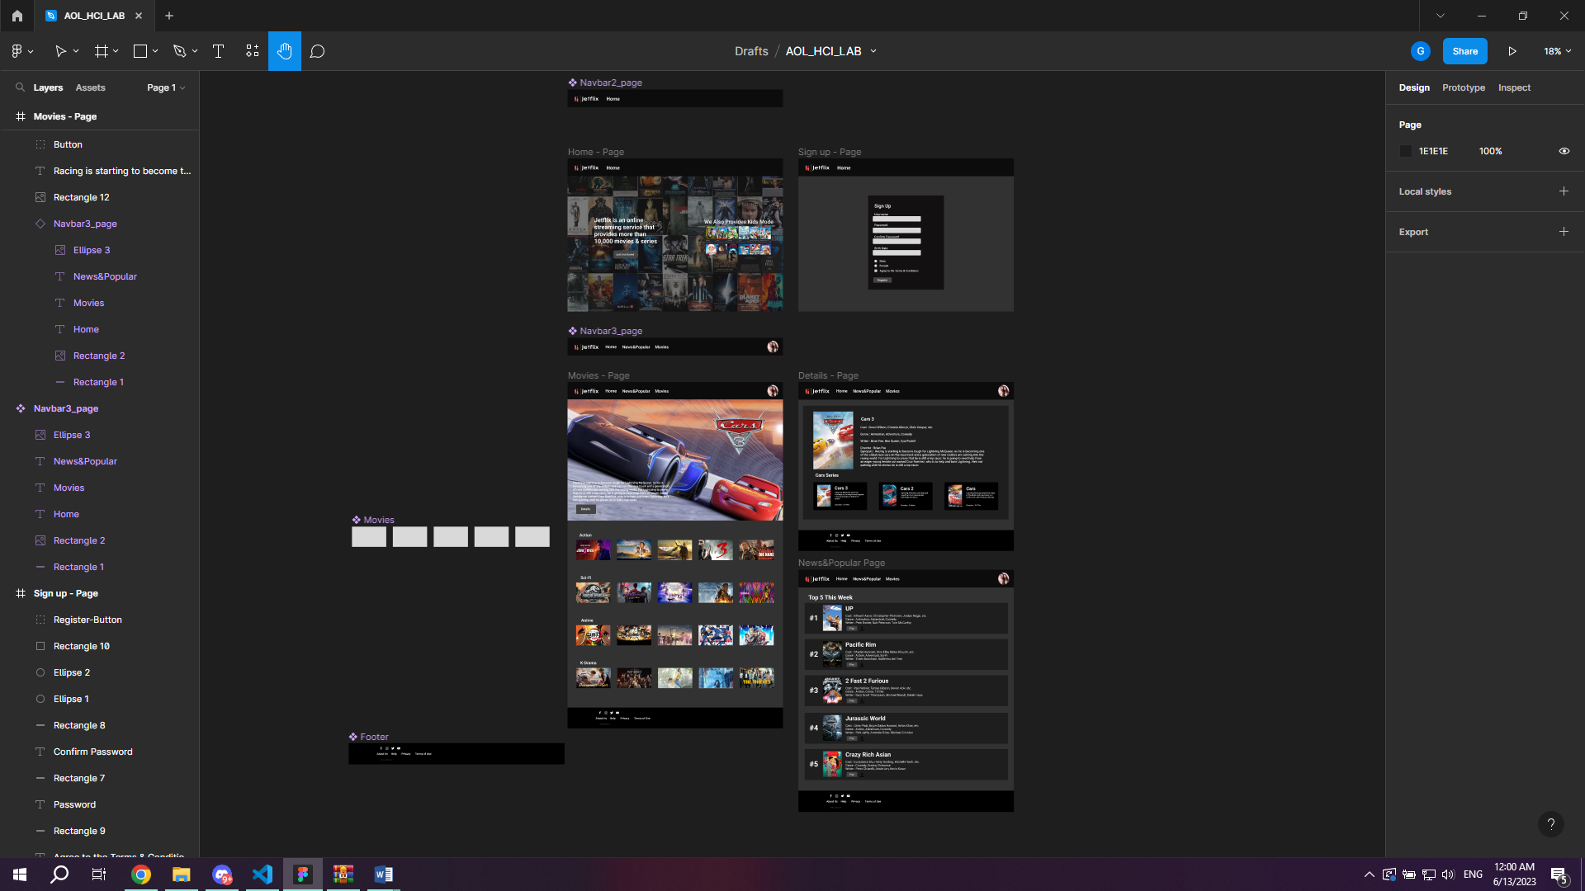

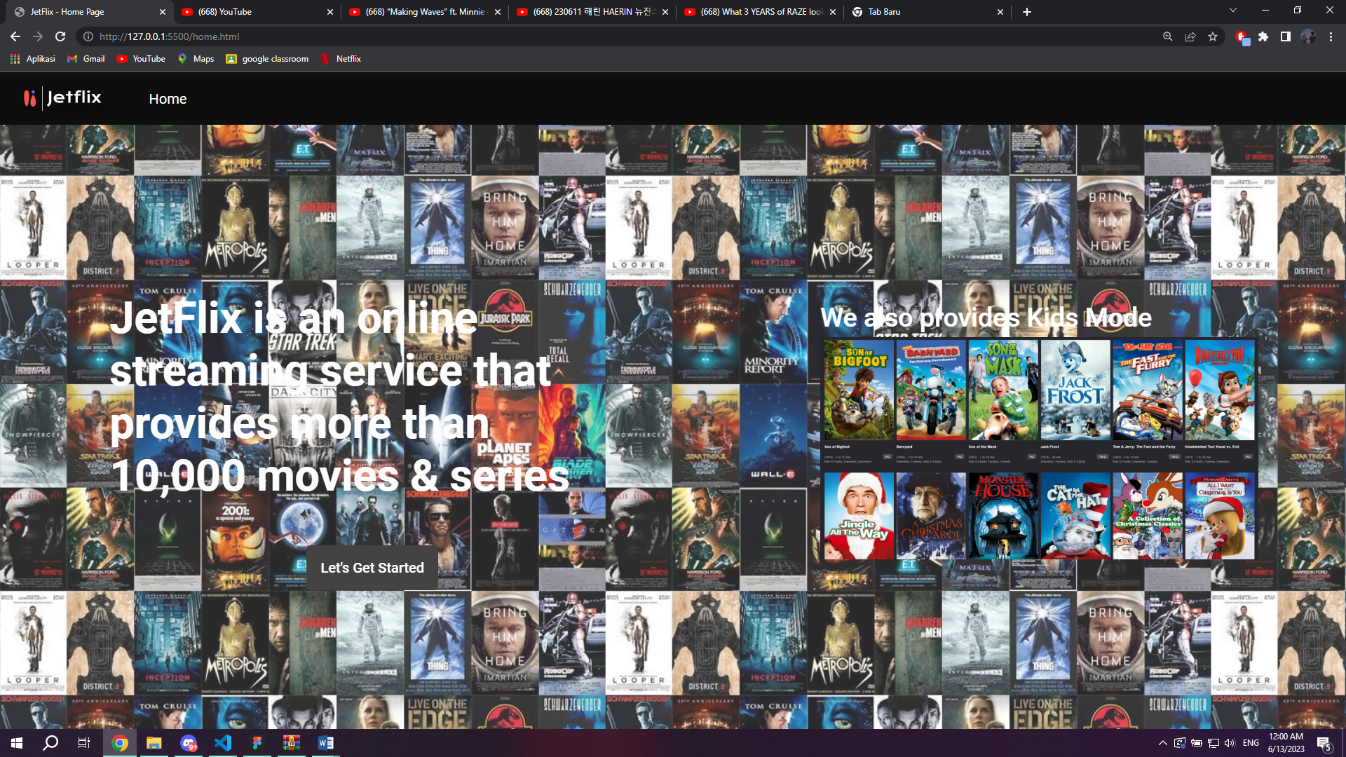

Gambar di atas merupakan homepage dimana user dapat mengetahui apa itu jetflix dan ada fitur kids mode

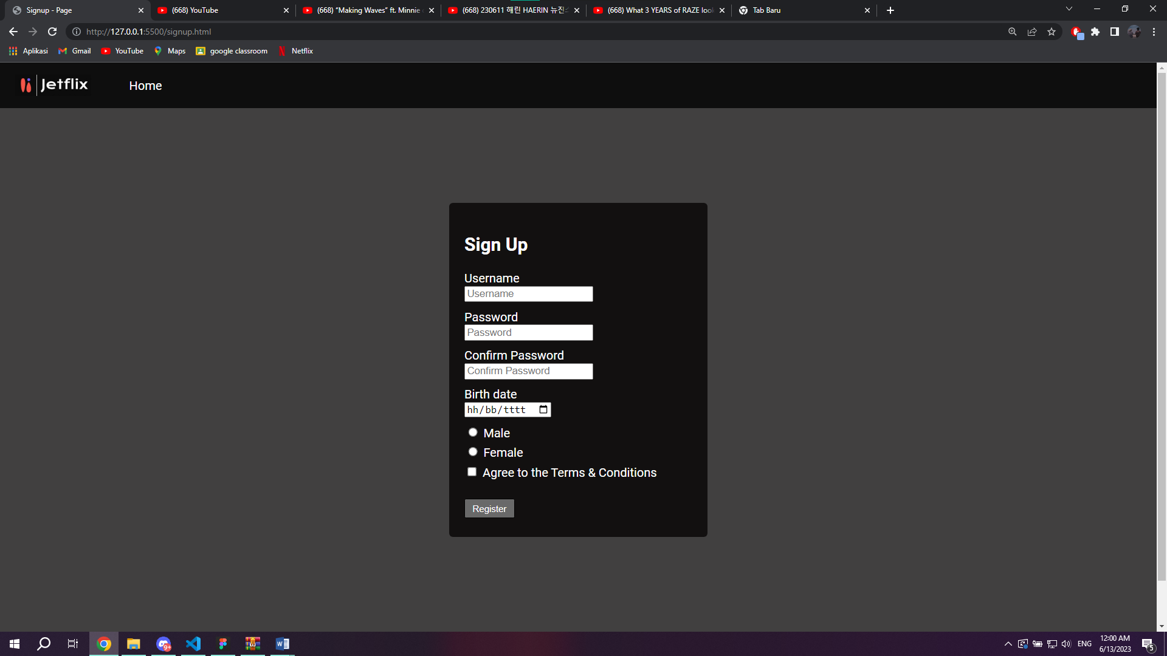

Sign up Page dengan beberapa validasi, seperti username harus lebih dari 5 char, password harus alphanumeric, confirm password harus sama dengan password, birthdate, gender, dan agree to terms & Conditions

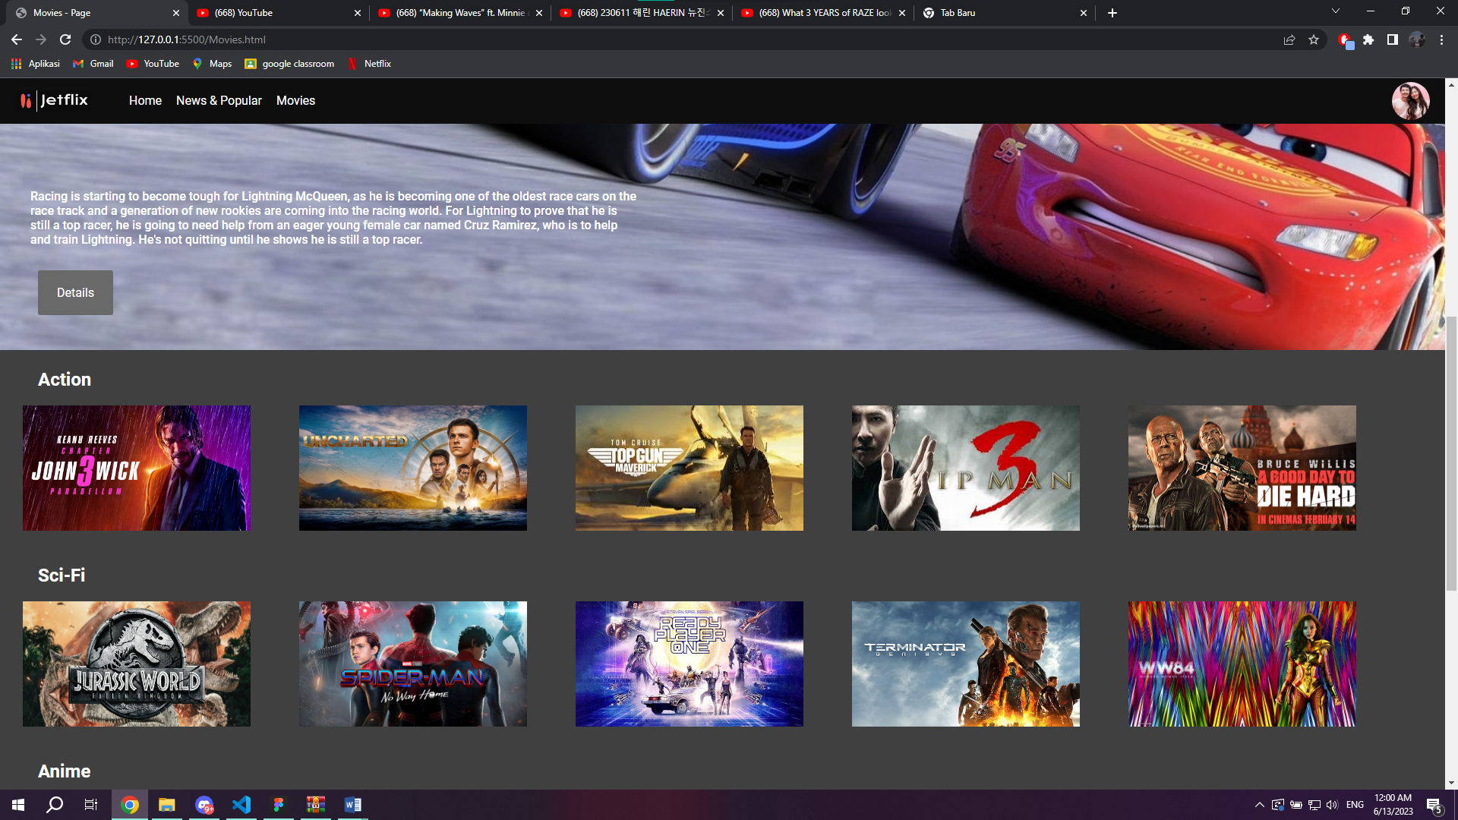

Movie Page yang berisi jumbotron beserta detailnya dan juga ada 4 category, yaitu Action, Sci-Fi, Anime, dan K-Drama dengan masing2 5 film.

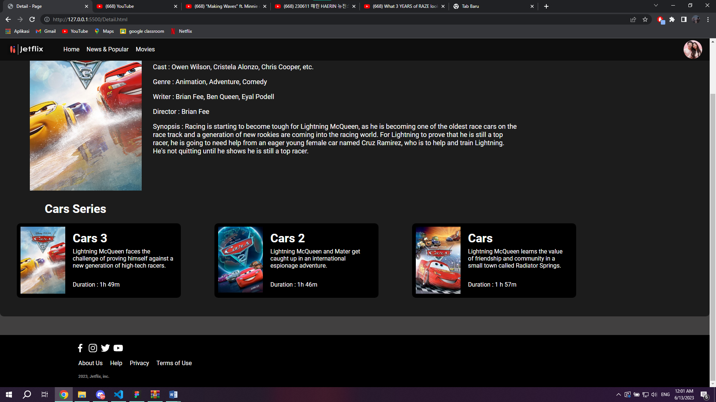

Detail page berisi info film yang berada di jumbotron dengan lengkap, seperti cast, genre, writer, director, dan juga synopsis. Kemudian di bagian bawah terdapat seri dari film yang ditampilkan, pada website ini ditampilkan seri dari cars, yaitu ada cars 1, 2, dan 3.

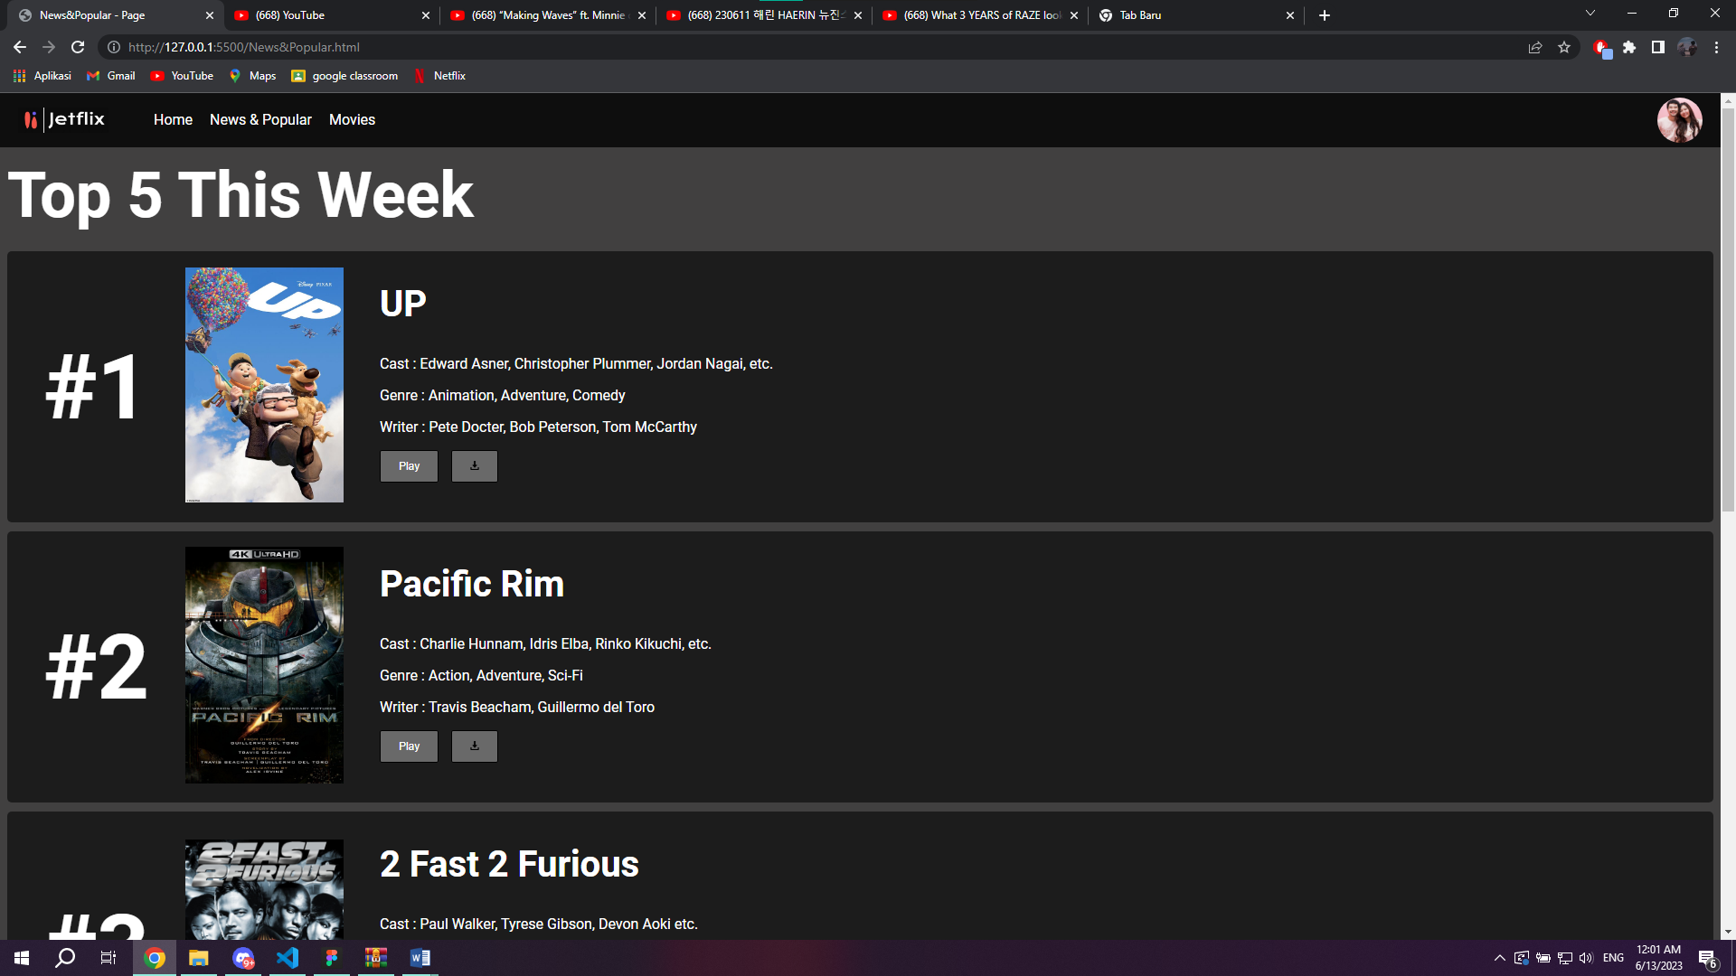

Pada page ini ditampilkan top 5 film yang sering ditonton oleh user. User dapat melihat informasi seputar film, seperti cast, genre, dan writer. Serta disediakan tombol play dan juga download agar user bisa langsung menonton dan mendownload film.

Beberapa dokumentasi coding  
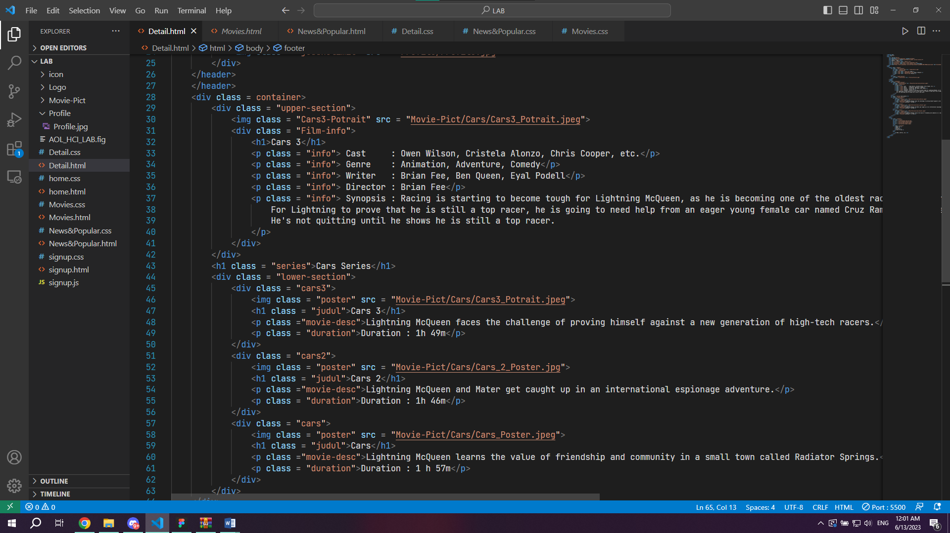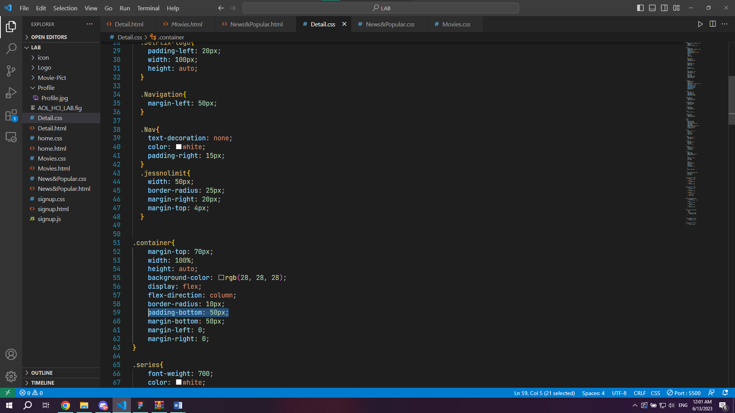

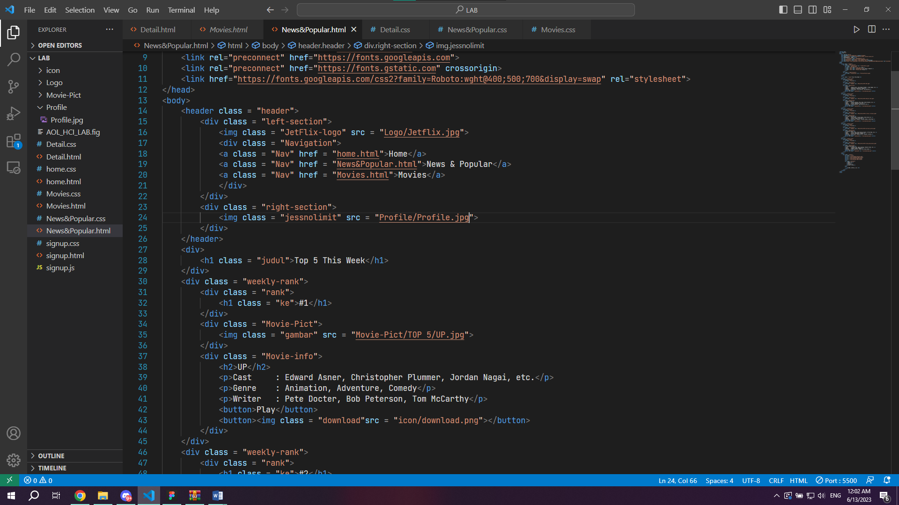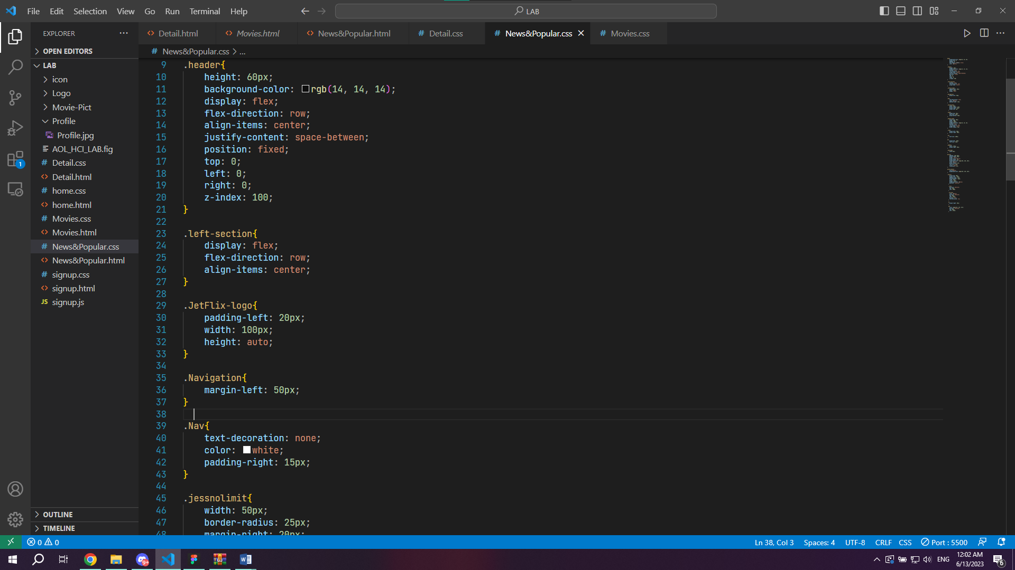

Link referensi pembuatan website

Diambil dari website:

* <https://www.primevideo.com/>
* <https://www.netflix.com/>

Referensi code:

* <https://youtu.be/G3e-cpL7ofc>
* <https://www.w3schools.com/css/default.asp>

Link assets yang saya gunakan

Home – Page:

* Logo : <https://manage.wix.com/>
* Background img: <https://twitter.com/OnlyFilmMedia/status/944620316533383170>
* Kids-Mode: <https://www.thetechedvocate.org/best-sites-for-free-kids-movies/>

Sign up – Page:

* Logo : <https://manage.wix.com/>

Movies – Page:

* Jumbotron : <https://amp.kompas.com/properti/read/2019/06/27/180000721/index.html>
* Die Hard: <https://autonetmagz.com/film-die-hard-5-hancurkan-banyak-mobil/246/>
* Ip Man 3: <https://www.bilibili.tv/id/video/2048828728>
* John Wick 3: <https://www.primevideo.com/detail/John-Wick-Chapter-3---Parabellum/0KEOQVCO1L34G43CF0ANQP3X98/ref=atv_nb_lcl_id_ID?ie=UTF8&language=id_ID>
* Top Gun: <https://www.tribunnews.com/seleb/2022/08/25/kisah-para-pilot-jet-tempur-top-gun-maverick-pernah-rajai-box-office-kini-bisa-ditonton-streaming>
* Uncharted: <https://www.themoviedb.org/movie/335787-uncharted/images/backdrops?image_language=en&language=id-ID>
* Jurrasic World: <https://www.bukalapak.com/p/komputer/aksesoris-226/flashdisk/2lzyrgf-jual-flashdisk-hp-64-gb-film-movie-box-office-hollywood-movies-android-murah-promo-bukan-dvd-cd>
* No way Home: <https://kincir.com/movie/cinema/spider-man-no-way-home-tobey-maguire-andrew-garfield-gabung-tanpa-naskah-C4Mu49LrYyRx>
* Ready Player One: <https://www.hipwee.com/list/8-easter-eggs-yang-luput-kamu-temukan-di-ready-player-one/>
* Terminator: <https://www.pxfuel.com/id/desktop-wallpaper-ullsk>
* Wonder Woman: <https://www.pxfuel.com/id/desktop-wallpaper-psqfy>
* AOT: <https://www.pxfuel.com/id/desktop-wallpaper-oymky>
* Blue Lock: <https://twitter.com/haruchivoo>
* Bunny Girl: <https://www.bilibili.tv/id/video/2043835376>
* Demon Slayer: <https://www.wallpaperbetter.com/id/search?q=rengoku+kyoujurou>
* SAO: <https://www.bilibili.tv/id/video/2007745786>
* Descendant of the suns: <https://surabaya.tribunnews.com/2019/01/12/kabar-terkini-pemain-drama-korea-descendants-of-the-sun-mayoritas-masih-aktif-bermain-film>
* Happines: <https://www.bilibili.tv/id/video/4786653889956864>
* Our Beloved Summer: <https://www.cnbcindonesia.com/lifestyle/20220124122028-33-309887/37-rekomendasi-drama-korea-terbaik-dari-lawas-sampai-terbaru>
* The Penthouse: <https://www.kompas.com/hype/read/2021/06/19/173554966/3-sekretaris-bermental-baja-dalam-drama-korea-the-penthouse>
* The Thieves: <https://www.konteks.co.id/lainnya/k-pop/52147/link-dan-sinopsis-5-film-hits-korea-serta-drakor-keren-bulan-januari-2023/>
* Icon: <https://boxicons.com/>
* Synopsis: <https://www.imdb.com/>

Detail-Page:

* Cars 3: <https://movies.disney.com/cars-3>
* Cars 2: <https://play.google.com/store/movies/details/Cars_2?id=b5zcpDE825k&hl=id&gl=US>
* Cars: <https://www.swimhereford.co.uk/genre/komedi/page/2/>
* Movie Info: <https://www.imdb.com/>
* Icon: <https://boxicons.com/>

News&Popular – Page:

* UP: <http://imungblog.blogspot.com/2012/09/grafik-komputer-dan-pengolahan-citra.html>
* Pacific Rim: <https://www.primevideo.com/detail/Pacific-Rim/0J4HNGRGAEBBZ4SIPATSP3S87J/ref=atv_nb_lcl_id_ID?ie=UTF8&language=id_ID>
* 2 Fast 2 Furious: <https://celebrity.okezone.com/read/2021/01/07/598/2340572/gtv-manjakan-penonton-kesayangan-dengan-2-film-hollywood-setiap-hari>
* Jurrasic World: <https://www.primevideo.com/detail/Jurassic-World/0TIVHLLYK99SWTW7MIVEZBZ2IA/ref=atv_nb_lcl_id_ID?language=id_ID&ie=UTF8>
* Crazy Rich Asian: <https://wolipop.detik.com/entertainment-news/d-5941948/sinopsis-crazy-rich-asians-film-spesial-valentine-di-bioskop-trans-tv-hari>
* Movie Info: <https://www.imdb.com/>
* Icon: <https://boxicons.com/>